|  |
| --- |
|  |
| Digiledger |
| Financial Data Operation and Processing System |
|  |
| **Group members: Amboya, Kenneth E.**  **Sicat, Arvey F. dela Cruz, March Enrico O.**  **Perez, Jhude Christoper L.** |
|  |

|  |
| --- |
|  |

**Module Name:** User Registration and login Module

**Purpose of the Module:**  
This module allows administrators or managers to create new user accounts, enabling them and other employees to log in to the system.

**Functionalities Included:**

* Creation of Account for the system users.
* Logging in to the system using the Account

**UI**

**Registration:** **Login:**

**Backend Logic Description**

**Registration:**  
When a user submits the registration form, the following steps occur on the backend:

1. **Data Reception:** The backend receives the data entered in the registration form fields (Name, EntityType, Username, Password, Email, Phone Number).
2. **Data Validation:** The system validates the received data to ensure its integrity. This may include checks for:
   * Presence of required fields.
   * Valid email format.
   * Uniqueness of the username.
   * Other relevant data constraints.
3. **Data Processing:** If the data is valid, the system proceeds to process it for account creation.
4. **Account Creation:** The system creates a new user account in the database using the processed data.
5. **Response Handling:**
   * **Success:** If the account creation is successful, the backend will send a success response.
   * **Failure:** If any issues arise during validation or account creation, the backend should generate an appropriate error message indicating the problem. This message would typically be displayed to the user on the frontend.

**Login:**When a user logins, the following steps occur on the backend:

1. **Data Reception:** The backend receives the data entered in the form fields (Username, Password).
2. **Data Processing:** If the data is found, the system proceeds to redirect the user to the dashboard.

**Database Tables Used**

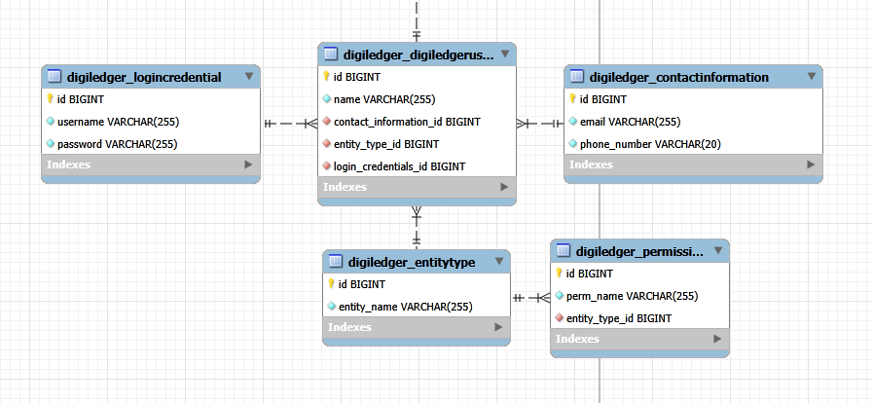

**Expected Input and Output:**

**Expected Input:**

The module expects the following input data, typically provided through the registration form:

* **Name:** A string representing the name of the new user account.
* **EntityType:** A selection representing the type or category of the user (e.g., Admin, Manager, Standard User). The specific options available would depend on the system's configuration.
* **Username:** A unique string that the user will use to log in.
* **Password:** A string that the user will use in conjunction with the username to authenticate.
* **Email:** A valid email address for the user's contact information.
* **Phone Number:** A string representing the user's phone number (format may vary depending on requirements).

**Expected Output:**

Upon successful completion of the registration process, the primary output is the creation of a new user account within the system's database. This includes storing the provided information (Name, EntityType, hashed Password, Email, Phone Number) associated with the unique Username.

Additionally, the backend produce the following outputs:

* **Success Response:** An indication to the frontend that the user account was created successfully. This will be a status code or a success message.
* **Error Messages:** If the registration fails due to validation errors (e.g., invalid email, non-unique username) or system errors (e.g., database connection issues), the backend should output specific error messages to inform the frontend about the cause of the failure.

**Module Name:** Transaction Recording And Tracking Module

**Purpose of the Module:**  
The purpose of this module is to provide the primary interface for recording financial transactions (journal entries) within the Digiledger system. These initial entries serve as the foundation for all subsequent financial reporting. The module ensures that each transaction is properly documented with relevant details (date, accounts affected, debit and credit amounts) and automatically updates the corresponding ledger accounts. Furthermore, it facilitates the generation of the trial balance, which summarizes all ledger account balances to ensure the fundamental accounting equation (Assets = Liabilities + Equity) is in balance.

**Functionalities Included:**

* **Journal Entry Creation**: Allows users to input and record new financial transactions with date, affected accounts, and debit/credit amounts.
* **Automatic Ledger Updates**: Automatically posts journal entries to the respective ledger accounts and maintains running balances.
* **Trial Balance Generation**: Aggregates ledger account balances into a trial balance report to verify accounting equation balance.
* **Balance Sheet: (Not implemented yet)** Will provide a snapshot of the company's assets, liabilities, and equity at a specific point in time.
* **Cash Flow Statement: (Not implemented yet)** Will track the movement of cash both into and out of the company over a period of time.
* **Income Statement: (Not implemented yet)** Will report the company's financial performance over a period of time, detailing revenues, expenses, and profit or loss.

**UI**

**Adding Entries:  
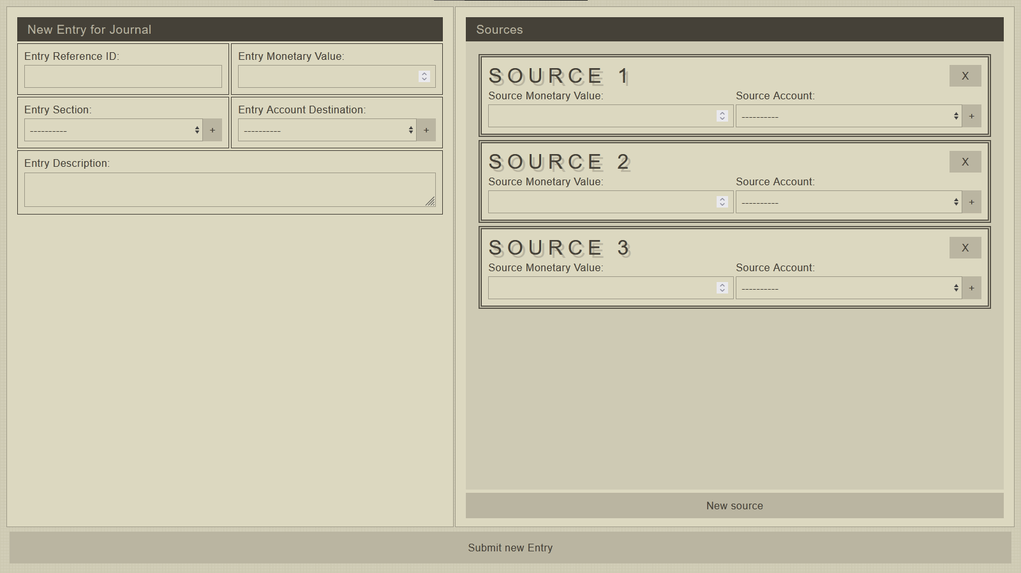  
Journals Entries:**

**Ledgers Entries:** **Trial Balance:** **(The last 3 hasn’t been implemented yet)**

**Backend Logic Description**

**New Entry:**  
When a user submits the registration form, the following steps occur on the backend:

1. **Data Reception:** The backend receives the data entered in the registration form fields (Name, EntityType, Username, Password, Email, Phone Number).
2. **Data Validation:** The system validates the received data to ensure its integrity. This may include checks for:
   * Presence of required fields.
   * Valid email format.
   * Uniqueness of the username.
   * Other relevant data constraints.
3. **Data Processing:** If the data is valid, the system proceeds to process it for account creation.
4. **Account Creation:** The system creates a new user account in the database using the processed data.
5. **Response Handling:**
   * **Success:** If the account creation is successful, the backend will send a success response.
   * **Failure:** If any issues arise during validation or account creation, the backend should generate an appropriate error message indicating the problem. This message would typically be displayed to the user on the frontend.

**Journal:**When a user want to view Journals, the following steps occur on the backend:

1. **Transaction Retrieval:** The system retrieves all recorded financial transactions from the database.
2. **Grouping by Account:** The retrieved transactions are then grouped based on the accounts they affect.
3. **Iterative Processing:** The system iterates through each group of transactions (belonging to a specific account).
4. **Appending to Container:** For each account, the associated transactions are appended to an appropriate data structure or container (e.g., a list or array). This organizes all transactions related to a single account together for display or further processing.

**Ledgers:**When a user want to view Ledgers, the following steps occur on the backend:

1. **Account Retrieval:** The system retrieves a list of all defined accounts within the financial system.
2. **Container Initialization:** For each retrieved account, the system creates an empty data structure or container to hold its related transactions.
3. **Transaction Retrieval:** The system retrieves all recorded financial transactions from the database.
4. **Transaction Iteration:** The system iterates through each individual transaction.
5. **Account Linking Check:** For each transaction, the system checks which accounts are linked to it.
6. **Appending to Container:** after the account is identified that transaction is appended to the container created for that account.

**Trial Balance:**When a user want to view Trial Balance, the following steps occur on the backend:

1. **Ledger Data Retrieval:** The system retrieves the processed data from the Ledgers (specifically, the ending balance for each account).
2. **Iterative Balance Processing:** The system iterates through the ending balances of each account.
3. **Debit/Credit Side Determination:** For each account balance, the system determines whether it is a debit balance or a credit balance.
4. **Placement in Report:** The account name and its corresponding balance are placed in either the debit column or the credit column of the trial balance report.
5. **Total Calculation:** The system calculates the sum of all debit balances and the sum of all credit balances.
6. **Balance Verification:** The system compares the total debits and total credits to ensure they are equal, indicating a balanced trial balance.

**Database Tables Used**

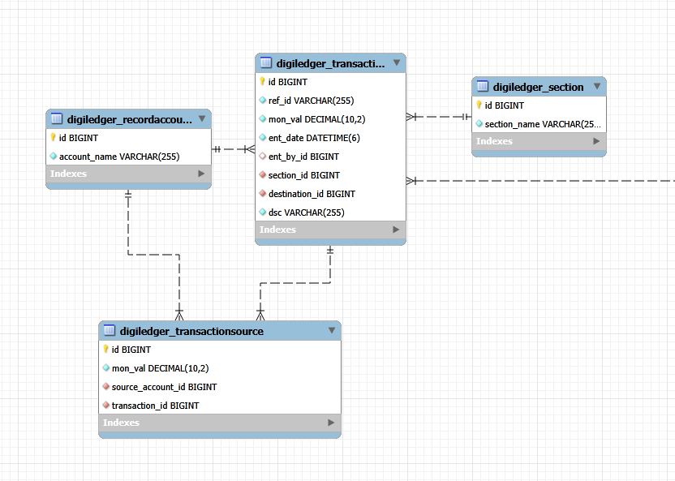

**Expected Input and Output:**

**Expected Input:**

1. **Journal Entry Creation:** User provides a transaction reference ID, destination account monetary value and name, a section name, description, and array of sources   
   (each source has a source_account_name and monetary_value).
2. **Automatic Ledger Updates:** Newly saved journal entry data (including details of destination and source accounts with their values) is the internal input.
3. **Trial Balance Generation:** Current balances of all ledger accounts are the internal input.

**Expected Output:**

1. **Journal Entry Creation:** Successful creation results in a new record in the journals container; failure results in specific error messages.
2. **Automatic Ledger Updates:** Corresponding ledger objects are updated in the container based on the journal entry details.
3. **Trial Balance Generation:** A report showing all accounts with their debit or credit balances and the total debits and credits, indicating if they balance.